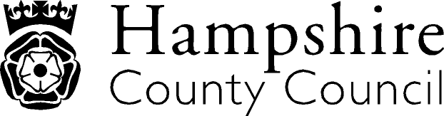

Year 1

The national curriculum for mathematics aims to ensure that all pupils:
- become fluent in the fundamentals of mathematics, including through varied and frequent practice with increasingly complex problems over time, so that pupils develop conceptual understanding and the ability to recall and apply knowledge rapidly and accurately.
- reason mathematically by following a line of enquiry, conjecturing relationships and generalisations, and developing an argument, justification or proof using mathematical language
- can solve problems by applying their mathematics to a variety of routine and non-routine problems with increasing sophistication, including breaking down problems into a series of simpler steps and persevering in seeking solutions.

Key performance indicator | Performance standard
Number and place value  Counts to and across 100, forwards and backwards, beginning with 0 or one, or from any given number  Counts, reads and writes numbers to 100 in numerals; counts in multiples of twos, fives and tens  Given a number, identifies one more and one less  Addition and subtraction  Represents and uses number bonds and related subtraction facts within 20  Multiplication and division  Use concrete objects, pictorial representations and arrays with the support of the teacher to solve one step problems involving multiplication and division  Fractions (including decimals)  Recognises, finds and names a half as one of two equal parts of an object, shape or quantity  Measurement  Compares, describes and solves practical problems for :  - lengths and heights eg long/short, longer/shorter, tall/short, double/half;  - mass/wight eg heavy/light, heavier than, lighter than;  - capacity and volume eg full/empty, more than, less than, half, half full, quarter; and  - time eg quicker, slower, earlier, later  Tells the time to the hour and half past the hour and draws the hands on a clock face to show these times  Properties of shape  Recognises and names common 2-D and 3-D shapes, including:  - 2-D shapes eg rectangles (including squares), circles and triangles;  - 3-D shapes eg cuboids (including cubes), pyramids and spheres | With reference to the KPIs  By the end of Y1, a child should be fluent with whole numbers and counting  A child has a developing knowledge of addition and subtraction using concrete objects and pictorial representations  A child is beginning to recognise simple fractions  A child can describe and compare different quantities such as length, mass and capacity/volume.  A child is beginning to tell the time.  Children should read and spell mathematical vocabulary at a level consistent with their increasing word reading and spelling knowledge at key stage 1

