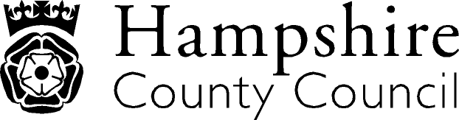

Year 6: Reading
The overarching aim for English in the national curriculum is to promote high standards of language and literacy by equipping pupils with a strong command of the spoken and written word, and to develop their love of literature through widespread reading for enjoyment. The national curriculum for English aims to ensure that all pupils:
- read easily, fluently and with good understanding
- develop the habit of reading widely and often, for both pleasure and information
- acquire a wide vocabulary, an understanding of grammar and knowledge of linguistic conventions for reading, writing and spoken language
- appreciate our rich and varied literary heritage write clearly, accurately and coherently, adapting their language and style in and for a range of contexts, purposes and audiences
- use discussion in order to learn; they should be able to elaborate and explain clearly their understanding and ideas
- are competent in the arts of speaking and listening, making formal presentations, demonstrating to others and participating in debate
Key Performance Indicator | Performance standard
Word Reading  - Applies a growing knowledge of root words, prefixes and suffixes (morphology and etymology) - as listed in English appendix 1 of the national curriculum document - both to read aloud and to understand the meaning of new words that are met.  Comprehension- Clarify  - Checks that the book makes sense to the reader, discussing the individual’s understanding and exploring the meaning of words in context.  Comprehension- Monitor and Summarise  - Summarises the main ideas drawn from more than one paragraph, identifying key details that support the main ideas.  Comprehension- Select and Retrieve  - Retrieves, records and presents information from non-fiction.  Comprehension- Respond and Explain  - Provide reasoned justifications for their views  - Participate in discussions about books that are read to them and those they can read for themselves, building on their own and others’ ideas and challenging views courteously  Inference  - Predicts what might happen from details stated and implied.  Language for Effect  - Discusses and evaluates the authors use language, including figurative language, considering the impact on the reader.  Themes and Conventions  - Recognise texts that contain features from more than one genre, or demonstrate shifts in formality  Identify themes and conventions in a wide range of writing e.g. flashacks | With reference to the KPIs  By the end of Year 6, a child’s reading should be fluent and effortless across all subjects, not just in English.  A child can:  - discuss the purpose(s) of the language that is read and understand why sentences are constructed as they are;  - focus on all the letters in a word so they do not, for example, read ‘invitation’ for ‘imitation’ simply because they may be more familiar with the first word;  - accurately read individual words, which might be key to the meaning of a sentence or paragraph, to improve age appropriate comprehension;  - read independently, including books they would not choose to read;  - compare characters, consider different accounts of the same event and discuss viewpoints (both of authors and of fictional characters), within a text and across more than one text;  - reflect on feedback regarding the quality of their explanations and contributions to discussions.  A child understands the majority of terms needed for discussing what they hear and read such as metaphor, simile, analogy, imagery, style and effect.  A child applies the skills of information retrieval eg in reading history, geography and science textbooks, and in contexts where they are genuinely motivated to find out information, such as reading information leaflets before a gallery or museum visit or reading a theatre programme or review.  

Itallics: NAHT KPI Red Text: NC/Hants KPI

