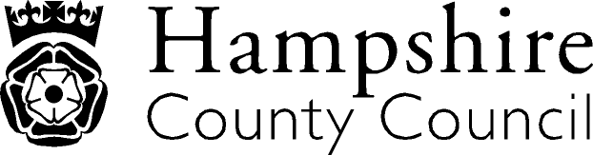

Year 5: Writing
The overarching aim for English in the national curriculum is to promote high standards of language and literacy by equipping pupils with a strong command of the spoken and written word, and to develop their love of literature through widespread reading for enjoyment. The national curriculum for English aims to ensure that all pupils:
- read easily, fluently and with good understanding
- develop the habit of reading widely and often, for both pleasure and information
- acquire a wide vocabulary, an understanding of grammar and knowledge of linguistic conventions for reading, writing and spoken language
- appreciate our rich and varied literary heritage write clearly, accurately and coherently, adapting their language and style in and for a range of contexts, purposes and audiences
- use discussion in order to learn; they should be able to elaborate and explain clearly their understanding and ideas
- are competent in the arts of speaking and listening, making formal presentations, demonstrating to others and participating in debate
Key Performance Indicator | Performance standard
Transcription  - Use knowledge of morphology and etymology in spelling and understand that the spelling of some words needs to be learnt.  Handwriting  - Write legibly, fluently and with increasing speed by choosing which shape of a letter to use when given choices and deciding whether or not to join specific letters.  Composition: Composition and Effect  - Identifies the audience for, and purpose of, the writing.  - Selects the appropriate form and uses other similar writing as models for their own  - Describes settings, characters and atmosphere.  Composition: Text Structure and Organisation  - Uses further organisational and presentational devices to structure text and to guide the reader (eg headings, bullet points, underlining).  - Use a wide range of devices to build cohesion within paragraphs  Composition: Sentence Structure  - Use a wide range of clause structures, sometimes varying their position within the sentence  Vocabulary, grammar and punctuation  - Proof-reads for spelling and punctuation errors.  - Ensures the consistent and correct use of tense throughout a piece of writing.  - Converts nouns or adjectives into verbs using suffixes (eg -ate; -ise; -ify).  - Indicates degrees of possibility using adverbs (eg perhaps, surely) or modal verbs (eg might, should, will, must).  - Uses commas to clarify meaning or avoid ambiguity. | With reference to the KPIs  By the end of Y5 a child should use accurate grammar and punctuation and begin to apply this when considering both audience and purpose.  A child can:  - structure and organise a range of texts effectively for different purposes;  - use knowledge of language gained from stories, plays, poetry, non-fiction and textbooks to facilitate writing;  - use vocabulary, grammar and punctuation concepts set out in English appendix 2 of the national curriculum documentation, and be able to apply them correctly to examples of real language, such as independent writing;  - write effective descriptions;  - apply a knowledge of linguistic terms, including those to describe grammar, so they can discuss their writing and reading;  - select a handwriting style appropriate to the task.  A child understands the differences between standard English and non-standard English and can apply what has been learnt, for example, in writing dialogue for characters .  

Italics: NAHT KPI Red Text: NC/Hants KPI

