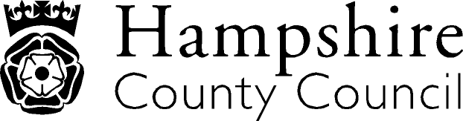

Year 3: Writing
The overarching aim for English in the national curriculum is to promote high standards of language and literacy by equipping pupils with a strong command of the spoken and written word, and to develop their love of literature through widespread reading for enjoyment. The national curriculum for English aims to ensure that all pupils:
- read easily, fluently and with good understanding
- develop the habit of reading widely and often, for both pleasure and information
- acquire a wide vocabulary, an understanding of grammar and knowledge of linguistic conventions for reading, writing and spoken language
- appreciate our rich and varied literary heritage write clearly, accurately and coherently, adapting their language and style in and for a range of contexts, purposes and audiences
- use discussion in order to learn; they should be able to elaborate and explain clearly their understanding and ideas
- are competent in the arts of speaking and listening, making formal presentations, demonstrating to others and participating in debate
Key Performance Indicator | Performance standard
Transcription  - Explores and accurately uses word families based on common words, showing how words are related in form and meaning e.g. solve, solution, solver, dissolve, insoluble  Handwriting  - Uses the diagonal and horizontal strokes that are needed to join letters and understand which letters, when adjacent to one another, are best left unjoined.  Composition and Effect  - In narratives, creates settings, characters and plot.  Composition: Text Structure and Organisation  - Organises paragraphs around a theme.  - Use simple organisational devices, e.g. headings and subheadings  Composition: Sentence Structure  - Draft and write an increasing range of sentence structures  Vocabulary, grammar and punctuation  - Introduces inverted commas to punctuate direct speech.  - Uses the forms ‘a’ or ‘an’ according to whether the next word begins with a consonant or a vowel eg. a rock, an open box.  - Uses the present perfect form of verbs instead of the simple past eg ‘He has gone out to play’ in contrast to ‘He went out to play’.  - Proof-reads for spelling and punctuation errors.  - Expresses time, place and cause using conjunctions. | With reference to the KPIs  By the end of Y3 a child should be able to write down their ideas with a reasonable degree of accuracy and with good sentence punctuation  A child can:  - spell common words correctly including exception words and other words that have been learnt (see appendix 1 of the national curriculum document);  - spell words as accurately as possible using phonic knowledge and other knowledge of spelling such as morphology and etymology;  - monitor whether their own writing makes sense in the same way that they monitor their reading, checking at different levels;  - write for a range of real purposes and audiences as part of their work across the curriculum in a variety of genres; and  - understand and apply the terminology and concepts set out in appendix 2 of the national curriculum document.  A child understands and applies the concepts of word structure (see appendix 2 of the national curriculum document).  A child is beginning to use joined handwriting throughout independent writing.  A child is beginning to understand the skills and processes that are essential for writing: that is, thinking aloud to explore and collect ideas, drafting, and re-reading to check the meaning is clear.  A child is beginning to understand how writing can be different from speech.  

Italics: NAHT KPI Red Text: NC/Hants KPI

