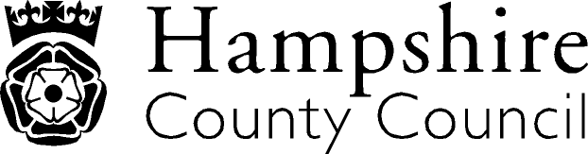

Year 3: Reading
The overarching aim for English in the national curriculum is to promote high standards of language and literacy by equipping pupils with a strong command of the spoken and written word, and to develop their love of literature through widespread reading for enjoyment. The national curriculum for English aims to ensure that all pupils:
- read easily, fluently and with good understanding
- develop the habit of reading widely and often, for both pleasure and information
- acquire a wide vocabulary, an understanding of grammar and knowledge of linguistic conventions for reading, writing and spoken language
- appreciate our rich and varied literary heritage write clearly, accurately and coherently, adapting their language and style in and for a range of contexts, purposes and audiences
- use discussion in order to learn; they should be able to elaborate and explain clearly their understanding and ideas
- are competent in the arts of speaking and listening, making formal presentations, demonstrating to others and participating in debate
Key Performance Indicator | Performance standard
Word Reading  - Reads further exception words, noting the unusual correspondences between spelling and sound, and where these occur in the word.  Comprehension- Clarify  - Use dictionaries to check the meaning of words they have read  Comprehension- Monitor and Summarise  - Identifies main ideas drawn from more than one paragraph and summarises these.  Comprehension- Select and Retrieve  - Retrieves and records information from non- fiction.  Comprehension- Respond and Explain  - Listen to and discuss a wide range of fiction, poetry, plays, non-fiction and reference books or textbooks  Inference  - Draw inferences such as inferring characters’ feelings, thoughts and motives from their actions  - Predict what might happen from details stated and implied  - Justify inferences with evidence  Language for Effect  - Identify how language, structure and presentation contribute to meaning  Themes and Conventions  - Identify themes and conventions in a wide range of books | With reference to the KPIs  By the end of Year 3 a child should be able to justify their views about books written at an age-appropriate interest level  A child is able to read the book accurately and at a speed that is sufficient for them to focus on understanding what they read rather than on decoding individual words  A child can:  - decode most new words outside the spoken vocabulary;  - read longer words with support and test out different pronunciations;  - recognise themes in what they read, such as the triumph of good over evil or the use of magical devices in fairy stories and folk tales;  - listen attentively and discuss books and authors that they might not choose themselves;  - read, reread and rehearse a variety of texts;  - use contents pages and indexes to locate information; and  - respond to guidance about the kinds of explanations and questions that are expected from them.  

Itallics: NAHT KPI Red Text: NC/Hants KPI

