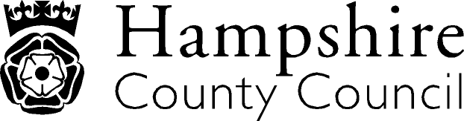

Year 2: Reading
The overarching aim for English in the national curriculum is to promote high standards of language and literacy by equipping pupils with a strong command of the spoken and written word, and to develop their love of literature through widespread reading for enjoyment. The national curriculum for English aims to ensure that all pupils:
- read easily, fluently and with good understanding
- develop the habit of reading widely and often, for both pleasure and information
- acquire a wide vocabulary, an understanding of grammar and knowledge of linguistic conventions for reading, writing and spoken language
- appreciate our rich and varied literary heritage write clearly, accurately and coherently, adapting their language and style in and for a range of contexts, purposes and audiences
- use discussion in order to learn; they should be able to elaborate and explain clearly their understanding and ideas
- are competent in the arts of speaking and listening, making formal presentations, demonstrating to others and participating in debate
Key Performance Indicator | Performance standard
Word Reading  - Reads accurately by blending the sounds in words that contain the graphemes taught so far especially recognising alternative sounds for graphemes.  - Reads accurately words of two or more syllables that contain the graphemes taught so far  - Reads most words quickly and accurately, without overt sounding and blending, when they have been frequently encountered  - Reads aloud books closely matched to their improving phonic knowledge, sounding out unfamiliar words accurately, automatically and without undue hesitation.  - Re-reads these books to build up their fluency and confidence in word reading.  Comprehension- Clarify  - Understand both the books they can already read accurately and fluently and those that they listen to  - Check that the text makes sense to them as they read and correcting inaccurate reading.  Comprehension- Monitor and Summarise  - Discuss the sequence of events in books and how items of information are related.  Comprehension- Select and Retrieve  - Answer questions  Comprehension- Respond and Explain  - Participate in discussions about books, poems and other works that are read to them and those that they can read for themselves, taking turns and listening to what others say.  Inference  - Predict what might happen on the basis of what has been read so far  Language for Effect  - Recognise simple recurring literary language in stories and poetry.  Themes and Conventions  - Listen to, discussing and expressing views about a wide range of contemporary and classic poetry, stories and non-fiction at a level beyond that at which they can read independently.  - Become increasingly familiar with and retell a wider range of stories, fairy stories and traditional tales  - Read non-fiction books that are structured in different ways | With reference to the KPIs  By the end of Y2, a child should be able to read books written at an age-appropriate interest level accurately and at a speed that is sufficient for a child to focus on understanding what is read rather than on decoding individual words  A child can:  - decode most new words outside the spoken vocabulary, making a good approximation to the word’s pronunciation  - listen to and discuss a wide range of stories, poems, plays and information books, including whole books;  - justify the views about what has been read with support;  - read suffixes by building on the root words that have already been learnt;  - exercise choice in selecting books;  - monitor what they read, checking that the word they have decoded fits in with whatever else they have read and makes sense in the context of what they already know about the topic;  - identify cause and effect in both narrative and non-fiction (e.g. what has prompted a character’s behaviour in a story; why certain dates are commemorated annually);  - take part in a discussion, considering the opinions of others.  

Itallics: NAHT KPI Red Text: NC/Hants KPI

