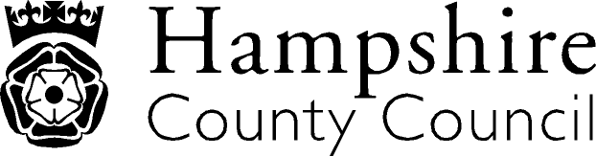

Year 1: Writing
The overarching aim for English in the national curriculum is to promote high standards of language and literacy by equipping pupils with a strong command of the spoken and written word, and to develop their love of literature through widespread reading for enjoyment. The national curriculum for English aims to ensure that all pupils:
- read easily, fluently and with good understanding
- develop the habit of reading widely and often, for both pleasure and information
- acquire a wide vocabulary, an understanding of grammar and knowledge of linguistic conventions for reading, writing and spoken language
- appreciate our rich and varied literary heritage write clearly, accurately and coherently, adapting their language and style in and for a range of contexts, purposes and audiences
- use discussion in order to learn; they should be able to elaborate and explain clearly their understanding and ideas
- are competent in the arts of speaking and listening, making formal presentations, demonstrating to others and participating in debate
Key Performance Indicator | Performance standard
Transcription  - Spells words containing each of the 40+ phonemes already taught.  - Names the letters of the alphabet in order.  - Write from memory simple sentences dictated by the teacher that include words using the GPCs taught so far  Handwriting  - Begins to form lower-case letters in the correct direction, starting and finishing in the right place.  Composition: Composition and Effect  - Re-read what they have written to check that it makes sense  Composition: Text Structure and Organisation  - Sequence sentences to form short narratives  Composition: Sentence Structure  - Write reliably formed simple and compound sentences  Vocabulary, grammar and punctuation  - Begin to punctuate sentences using a capital letter and a full stop Begin to punctuate sentences using a question mark  - Begin to punctuate sentences using an exclamation mark | With reference to the KPIs  By the end of Y1 a child should be able to compose individual sentences orally and then write them down and be able to spell correctly many of the words covered in Y1 (see appendix 1 of the national curriculum document) as well as name the letters of the alphabet in order  A child is able to make phonically-plausible attempts to spell words that have not yet been learnt and can form individual letters correctly  A child can:  - sound and blend unfamiliar printed words quickly and accurately using the phonic knowledge and skills that have already been learnt;  - read back words that have been spelt;  - spell some words in a phonically plausible way, even if sometimes incorrectly;  - write simple dictated sentences that include words taught so far;  - demonstrate the skills and processes essential to writing by thinking aloud as they collect ideas, sequence the ideas, draft and re-read to check that the meaning is clear;  - recognise sentence boundaries in spoken sentences and use the vocabulary listed in appendix 2 of the national curriculum document when writing is discussed.  A child is able to form letters correctly and confidently.  A child is beginning to use some of the distinctive features of standard English in their writing. ‘Standard English’ is defined in the glossary.  

Italics: NAHT KPI Red Text: NC/Hants KPI

