Addition | Subtraction | Key strategies (Q1-15)
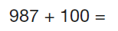 |  | - PV calculations  - Number bonds to 10, multiples of 10/100  - HTU-U  - Logic/ inverse/ missing box  - Mental ( facts and related facts)/ written  - Checking strategy for reasonable answer: rounding (related fact) and jottings on number lines  - Formal methods
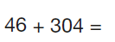 | 

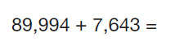(Y5)

(Y5)
Multiplication | Division | Key Strategies (Q1-15)
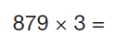 |  | - Related facts: ( x4, x8, ÷4,÷8) and 70 x8 + 1x 8  - PV Partitioning HTU  - Multiplying multiples of 10- building up facts eg 5x7 so 5x70 so 50x70  - Multiplying by 10/100  - Checking strategy for reasonable answer: rounding, x10/100, ÷10/100  - Using multiplication fact to check division eg 4x?=96  - Formal methods
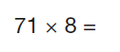 | 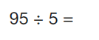
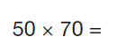 (Y5) | 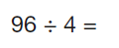
 (Y5) | 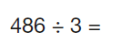(Y5)

